**Ex No:02 DML Commands**

**Aim:**

To work with DML commands

**Procedure:**

Step1: Open Run SQL on Command line and connect to SQL .

Step 2: Then work with database using SQL queries

**1.INSERT:**

**Syntax:** INSERT INTO table_name(column_name1,…,column_name_n) VALUES (value1, value2,…,valueN);

**Code:** insert into tution(rollno,name,standard,subjects,shift,fee) values(1,’Balan’,12,’Maths’,1,3500);

**OUTPUT:**

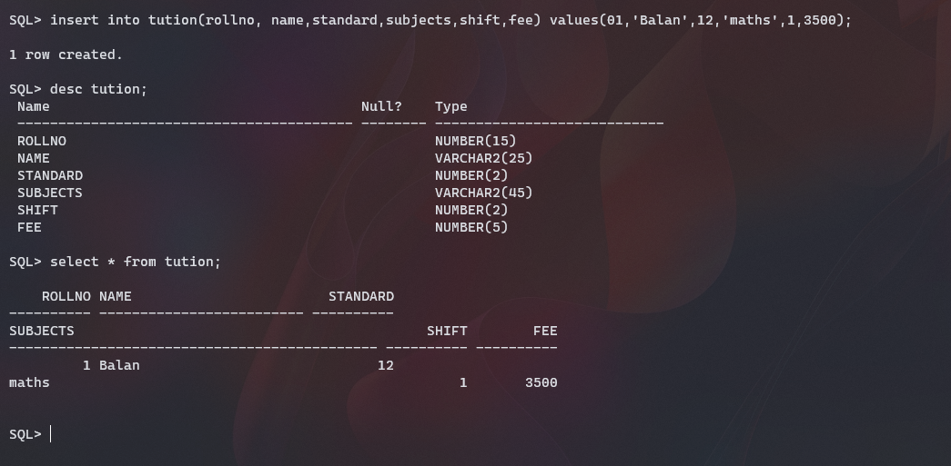

**2.SELECT:**

**Syntax:** SELECT column_name1, column_name2,…,column_name_n FROM table_name WHERE condition_expression;

**Code:** select rollno,name,standard,subjects from tution where fee>4500;

**OUTPUT:**

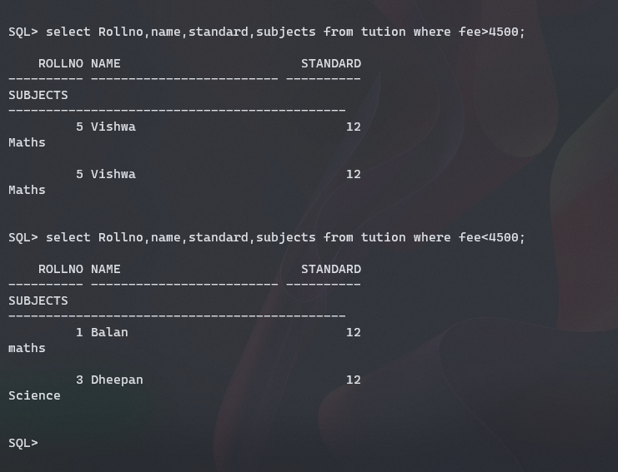

**3.UPDATE:**

**Syntax:** UPDATE table_name SET column_name1+value1, column_name2=value,… WHERE condition;

**Code:** update tution set standard=12 where name= ’Niteesh’;

**4.DELETE:**

**Syntax:** DELETE FROM table_name WHERE condition;

**Code:** delete from tution where rollno=5;

**OUTPUT:**

